AD006 Associate Degree in Information Technology
Course Code and Title : INTE2507, Enterprise Virtualization
Assessment Number 1a
Practical LabTest-A, Semester2, 2024
Weighting | 15% | Due Date | Friday, 30 Aug 2024, 5:30pm
Teacher | Aminul Islam | Contact details | Aminul.islam@rmit.edu.au
Individual or Group Assessment | Individual

LabTest Instructions :
- This is an Open Book Lab Test. Student may review Canvas weekly study materials and third-party study materials during the practical Lab Test.
- There are 5 Tasks, each task carries 3 marks.
- This assessment task is expected to take maximum of 1 hour.

Task
Student is required to install and configure Type Hypervisor – VMware ESXi Server as per Tasks instructions. Make any appropriate settings and configuration changes to complete the required Tasks. Provide screen-prints in Observation checklist.

Task1 : Configure Virtual Network
Task2 : Configure Multiple Network Cards and Datastore
Task3 : Create Virtual Machine
Task4 : Create User Account
Task5 : Run Shell Commands

What is being assessed
In this assessment, the following course outcomes are being assessed:
1. Understand the business case for virtualisation
2. Understand how commercial considerations influence IT design decisions
3. Apply an understanding of scale problems in environment design
4. Build a virtual environment
5. Maintain a virtual environment
The following program outcomes are incorporated into this assessment task:
• Enabling knowledge:
• Critical analysis
• Problem Solving
• Communication

Assessment details
Task1 : 3 Marks
-Set management NIC (nic0) to Subnet 19.29.39.0/24 Host-only network and set Host IP to 19.29.39.99
-Connect three(3) additional NICs to NAT
-Set ESXi Hostname with your StudentID , example. S0123456789ESXi1
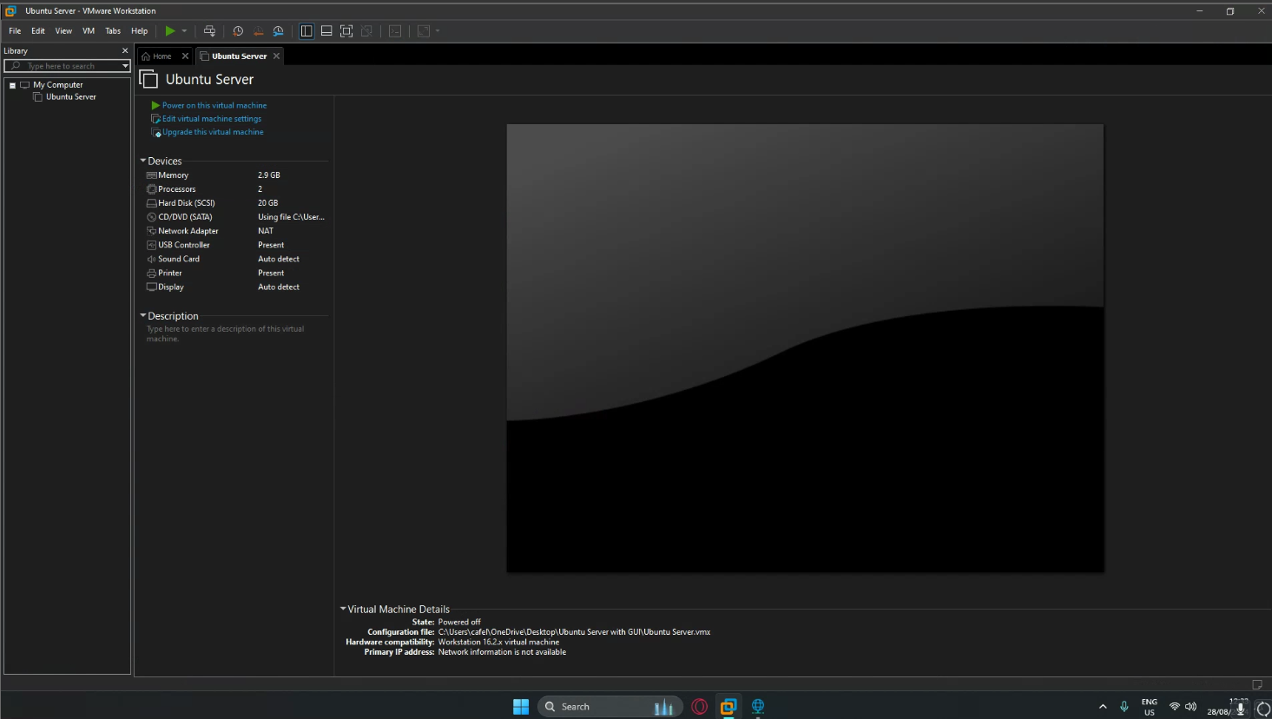

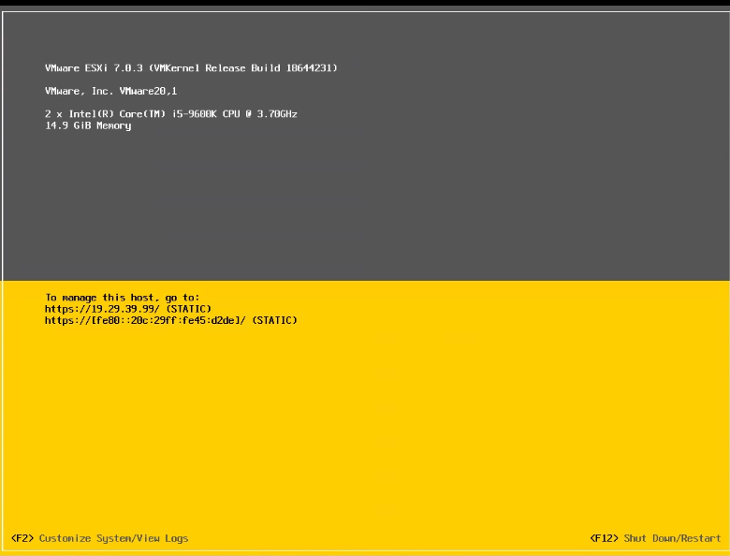
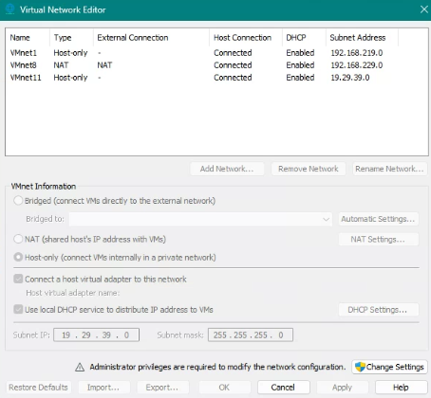
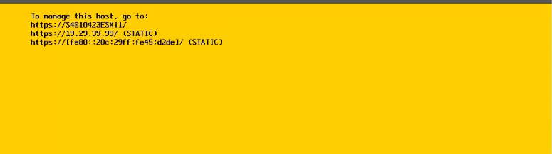
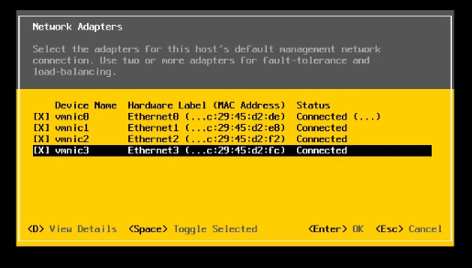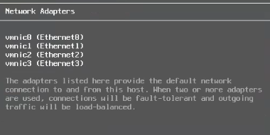
Task2 : 3 Marks
-Create a vSwitch name "vSW_FileServers" and connect the three(3) NAT NICs in Task1 as NICTeam with one NIC standby.
-Add a 2nd Disk of size 200GB, then create a 2nd Datastore of 100Gb from the 2nd Disk.
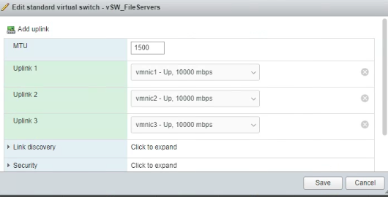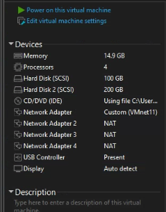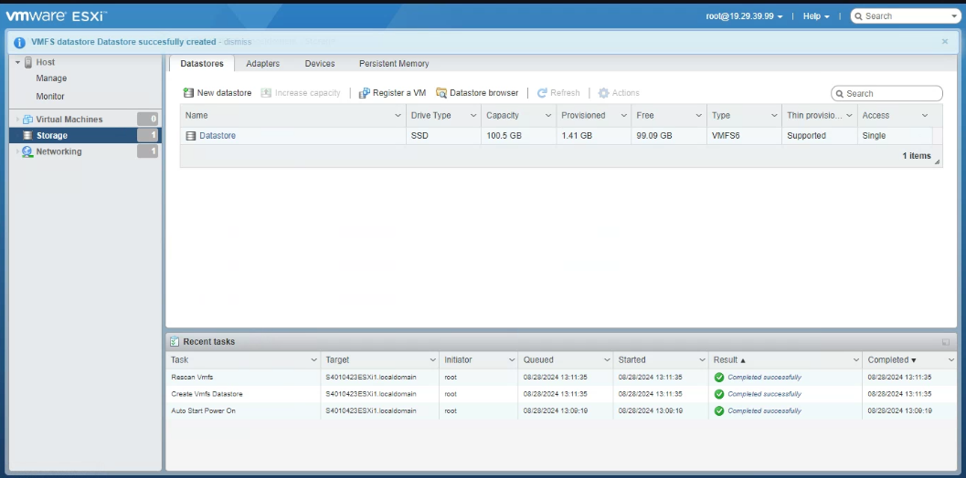
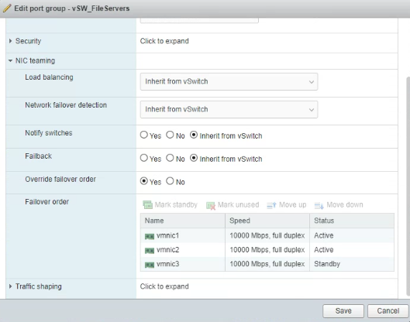
Task3 : 3 Marks
-Create a Virtual Machine profile for Windows Server 2019/2022, save it to the 2nd Datastore in Task2, and connect the VM to both vSwitches.
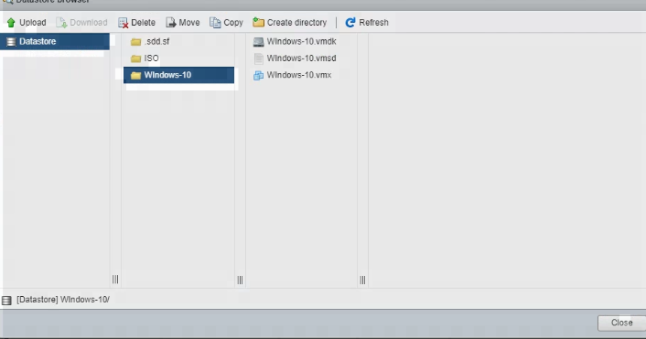
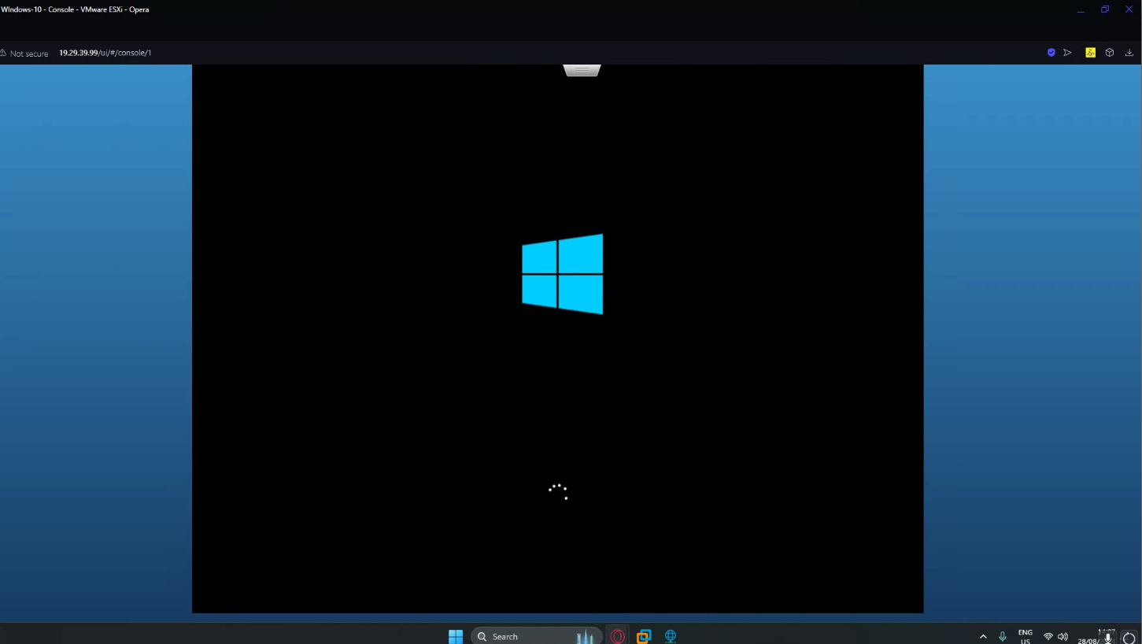
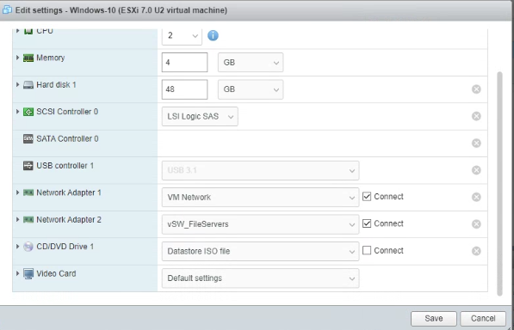

Task4 : 3 Marks
-Using DCUI, create a User account with Administrator permission in ESXi Server, use your StudentID as the username. Then login to the ESXi Server using this User Account.
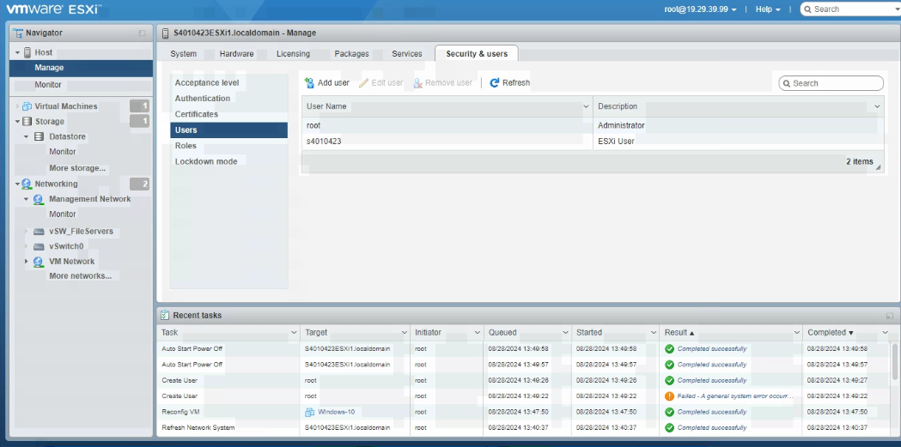

Task5 : 3 Marks
-Remotely Connect to ESXi Host and display the following information
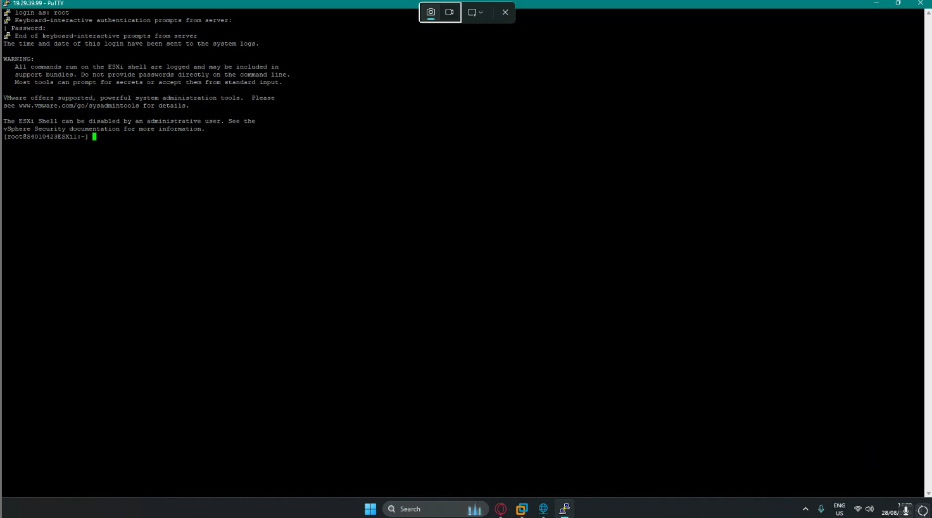
-Lists the local users on the ESXi host.
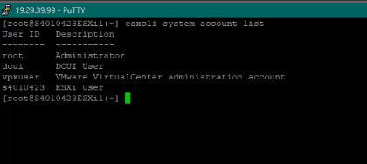
-Display NIC list
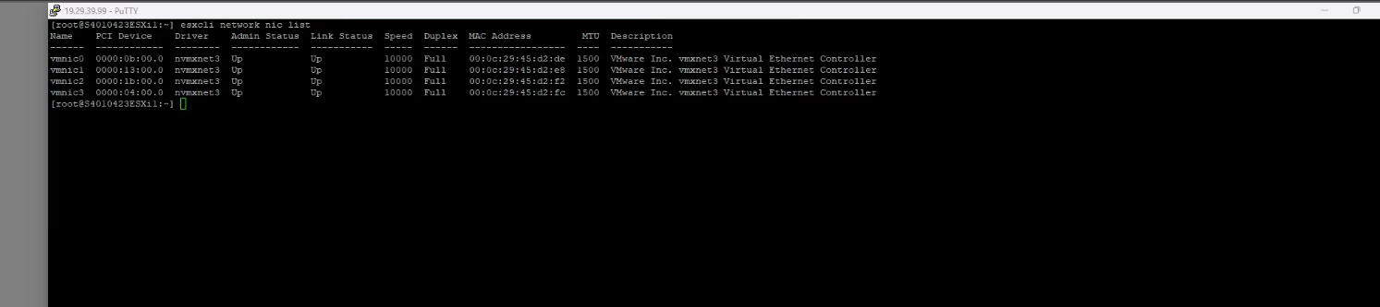
-Displays the IP configuration of Host ESXi.
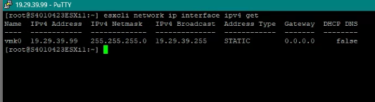
-Display VM list on the ESXi Host
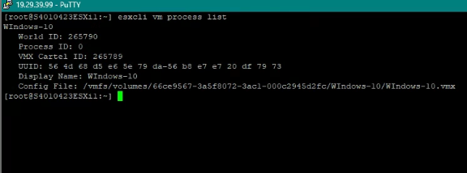

Presentation requirements
- Demonstrate your completed Lab Tasks to Examiner
- Take appropriate screen-prints for each task and submit document in Canvas.

Assessment criteria
You will be assessed on the following criteria:
- You will be assessed for each Task against the criteria as listed in the rubric/observation checklist.
- To achieve a satisfactory result, you will need to address all criteria satisfactorily.
Refer to the assessment rubric for grading.
Rubric for grading
INTE2507-Virtualization Labs Assignment A - Practical assessment marking guide
Criteria for each Task | Ratings | Pts
This criterion is linked to a Learning Outcome INTE2507-Virtualization Labs A  -Provided enough screen-prints to demonstrate the flow of the Lab works from start to completion.  -Provided screen-prints are clear enough to demonstrate the flow of the Lab works.  -Provided screen-prints are not clear enough to demonstrate your own works  -Did not submit screen-prints in .zip file or in separate folders. Provided the Screen-sprints in the Lab demonstration document provided.  -No distracted, Colorful or Black background, and the screen-print is of the whole desktop, showing the Lab -Windows, Taskbar, Date and Time  -Renamed the document, replace the word "StudentID-or_Name" with your StudentID or Name |  | 3 pts
  3 pts  Satisfactory  Clear and concise response, adequate screen-prints to demonstrate the flow of work, Identified by ID or Name, completed without any assistance. | 1.5 pts  Acceptable  Not enough screen-prints to demonstrate flow of work, required assistance, not identified by ID or Name in the screen-prints, require improvements | 0 pts  Not Satisfactory  No submission, Not enough screen-prints to demonstrate flow of work, submission by external link, unable to provide acceptable response to questions, screen-prints not Identified by ID or Name, unable to follow instructions.
Total Points: 3

Submission requirements
- Take appropriate screen-prints for each task and submit document in Canvas.

Academic integrity
It is important that you submit material which is your own work. The University provides information for students on academic Integrity through the RMIT website. If you are unsure about academic matters, please be sure to ask your teacher for information.
Assessment Policy
Assessments submitted after the due date will be accepted as follows:
- Assessments submitted between 0-24 hours after the due date: 20% penalty
- Assessments submitted between 24-48 hours after the due date: 50% penalty
- Assessments submitted more than 48 hours after the due date will not be accepted

Observation Check List
Task | Artifact / Screen Prints | Marks
Task1 : 3 Marks
-Set management NIC (nic0) to Subnet 19.29.39.0/24 Host-only network and set Host IP to 19.29.39.99
-Connect three(3) additional NICs to NAT

-Set ESXi Hostname with your StudentID , example. S0123456789ESXi1

Task2 : 3 Marks
-Create a vSwitch name "vSW_FileServers" and connect the three(3) NAT NICs in Task1 as NICTeam with one NIC standby.

-Add a 2nd Disk of size 200GB, then create a 2nd Datastore of 100Gb from the 2nd Disk.

Task3 : 3 Marks
-Create a Virtual Machine profile for Windows Server 2019/2022, save it to the 2nd Datastore in Task2, and connect the VM to both vSwitches.

Task4 : 3 Marks
-Using DCUI, create a User account with Administrator permission in ESXi Server, use your StudentID as the username. Then login to the ESXi Server using this User Account.

Task5 : 3 Marks
-Remotely Connect to ESXi Host and display the following information
-Lists the local users on the ESXi host.
-Display NIC list
-Displays the IP configuration of Host ESXi.
-Display VM list on the ESXi Host

